Public Lands Act
Application for Temporary Field Authorization
Personal Use Recreational Docks

- Applicant Information
  - Name of Individual: Click here to enter text.
Client ID: Click here to enter text.
If you do not have a client ID fill out the on-line application and e-mail to crownlanddata@gov.ab.ca
Address: Click here to enter text.
City: Click here to enter text. Province/Territory: Choose an item.
Postal Code: Click here to enter text. Phone number: Click here to enter text.
Fax number: Click here to enter text. Email: Click here to enter text.
.
Are you 18 years of ago or older? ☐ Yes ☐ No

  - Are you an employee of the Government of Alberta (GOA) or member of the Legislative Assembly? Choose an item.
If you are a GOA employee, attach approval from the Deputy Minister of your department in accordance with the Code of Conduct & Ethics for the Public Service of Alberta. If you are an MLA, please determine what approval documentation must be submitted with this application and attach.

☐ Approval attached

2.0 General Information
  - Proposed activity (check all that apply):
☐ Dock ☐ Swimming Platform ☐ Mooring Buoy ☐ Boat Lift(s)
  - Is this a new or existing mooring structure? ☐ Existing ☐ New
  - Activity footprint
Size (m²) of dock terminal platform: Click here to enter text.
Width (m) of dock walkway: Click here to enter text.
Number of boat lifts per dock: Click here to enter text.
Size (m²) of swimming platform: Click here to enter text.

3.0 Legal Land Location
3.1 Are you the waterfront lot owner or lease holder? ☐ Yes ☐ No
If you are not the waterfront landowner, attach consent of the waterfront landowner.
Legal Land Location of the waterfront parcel
Lot | Block | Plan Number | or | Title Number
or
LSD | QTR | Sec | TWP | RGE | M

4.0 Statutory Declaration
  - Statutory Declaration
Waterfront holders
I, Click here to enter text. of Click here to enter text., in the Province of Alberta, do solemnly declare that I am either: a) the person who is registered under the Land Titles Act as the owner of the fee simple estate in the land directly adjoining the bank of the applicable water body, or b) the holder of a lease according to the records of Alberta Environment and Parks for the land directly adjoining the bank of the applicable water body, AND I MAKE this solemn declaration conscientiously believing it to be true and knowing that it is of the same force and effect as if made under oath.

5.0 Consent
5.1 Non-Waterfront Holders
Non-waterfront landowners and semi-waterfront landowners or holders whose lands abut the boundary of a municipal reserve parcel that is waterfront, must provide written proof that the waterfront holder (e.g., the municipality that owns the environmental or municipal reserve parcel) has consented to the placement of a dock in front of the land parcel.
☐ Consent attached

.
Privacy statement
The personal information contained on this form is collected under the authorization of Section 33(c) of the Freedom of Information and Protection of Privacy (FOIP) Act and is managed in accordance with Part 2 of the FOIP Act. It will be used for the purpose of monitoring public land utilization in accordance with the Public Lands Act. Alberta Environment and Parks will disclose all information contained on this form, including personal information, to anyone requesting a copy in accordance with Section 166-167 of the Public Lands Administration Regulation. For further information, please contact Provincial Programs Branch, Operations Division, Alberta Environment and Parks, 5th Floor, South Petroleum Plaza, 9915-108 Street, Edmonton, Alberta, T5K 2G8. Telephone 780-427-3570.

6.0 Sketch Plan
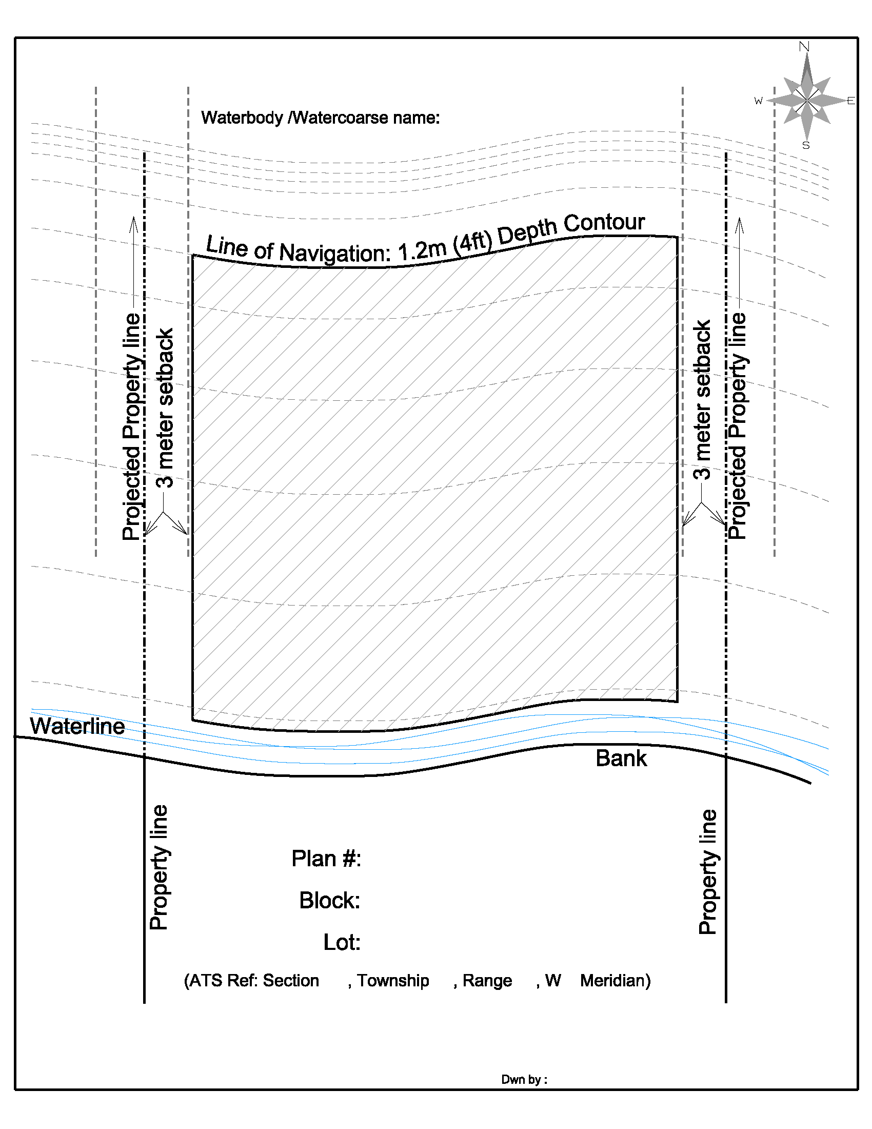
Alberta Environment and Parks has established that the acceptable footprint of a dock for personal recreational use should not extend beyond the Line of Navigation or not occupy more than 50% of the available defined mooring area.For the specific lot, sketch within the shaded area all associated structures and their dimensions, and note the number of watercraft to be moored.

